SQL> CREATE TABLE Employee (empno NUMBER(10), ename VARCHAR(20), job VARCHAR(20), sal VARCHAR(10));

Table created.

SQL> INSERT INTO Employee VALUES(&empno,'&ename','&job',&sal);

Enter value for empno: 6

Enter value for ename: ajay

Enter value for job: manager

Enter value for sal: 45678

old 1: INSERT INTO Employee VALUES(&empno,'&ename','&job',&sal)

new 1: INSERT INTO Employee VALUES(6,'ajay ','manager',45678)

1 row created.

SQL> INSERT INTO Employee VALUES(&empno,'&ename','&job',&sal);

Enter value for empno: 1

Enter value for ename: abin

Enter value for job: developer

Enter value for sal: 12300

old 1: INSERT INTO Employee VALUES(&empno,'&ename','&job',&sal)

new 1: INSERT INTO Employee VALUES(1,'abin','developer',12300)

1 row created.

SQL> /

Enter value for empno: 2

Enter value for ename: abhirami

Enter value for job: tester

Enter value for sal: 300000

old 1: INSERT INTO Employee VALUES(&empno,'&ename','&job',&sal)

new 1: INSERT INTO Employee VALUES(2,'abhirami','tester',300000)

1 row created.

SQL> /

Enter value for empno: 3

Enter value for ename: aditya

Enter value for job: trainee

Enter value for sal: 25000

old 1: INSERT INTO Employee VALUES(&empno,'&ename','&job',&sal)

new 1: INSERT INTO Employee VALUES(3,'aditya','trainee',25000)

1 row created.

SQL> 19

SP2-0226: Invalid line number

SQL> /

Enter value for empno: 19

Enter value for ename: amal

Enter value for job: manager

Enter value for sal: 100000

old 1: INSERT INTO Employee VALUES(&empno,'&ename','&job',&sal)

new 1: INSERT INTO Employee VALUES(19,'amal','manager',100000)

1 row created.

SQL> SELECT * FROM Employee;

EMPNO ENAME JOB SAL

---------- -------------------- -------------------- ----------

6 ajay manager 45678

1 abin developer 12300

2 abhirami tester 300000

3 aditya trainee 25000

19 amal manager 100000

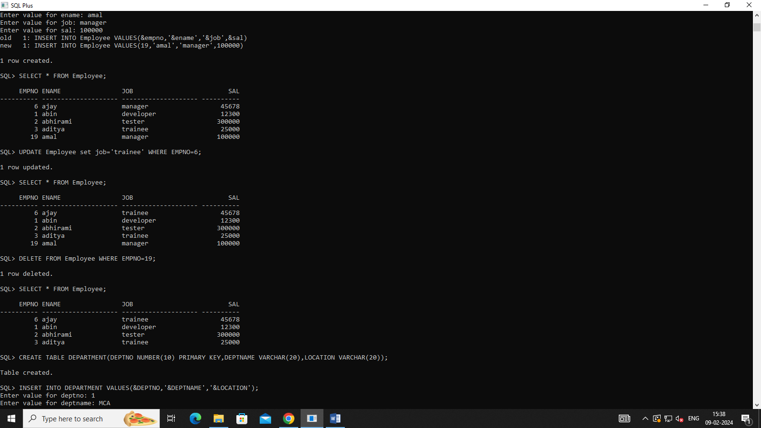

SQL> UPDATE Employee set job='trainee' WHERE EMPNO=6;

1 row updated.

SQL> SELECT * FROM Employee;

EMPNO ENAME JOB SAL

---------- -------------------- -------------------- ----------

6 ajay trainee 45678

1 abin developer 12300

2 abhirami tester 300000

3 aditya trainee 25000

19 amal manager 100000

SQL> DELETE FROM Employee WHERE EMPNO=19;

1 row deleted.

SQL> SELECT * FROM Employee;

EMPNO ENAME JOB SAL

---------- -------------------- -------------------- ----------

6 ajay trainee 45678

1 abin developer 12300

2 abhirami tester 300000

3 aditya trainee 25000

2.

SQL> CREATE TABLE DEPARTMENT(DEPTNO NUMBER(10) PRIMARY KEY,DEPTNAME VARCHAR(20),LOCATION VARCHAR(20));

Table created.

SQL> INSERT INTO DEPARTMENT VALUES(&DEPTNO,'&DEPTNAME','&LOCATION');

Enter value for deptno: 1

Enter value for deptname: MCA

Enter value for location: SJCET

old 1: INSERT INTO DEPARTMENT VALUES(&DEPTNO,'&DEPTNAME','&LOCATION')

new 1: INSERT INTO DEPARTMENT VALUES(1,'MCA','SJCET')

1 row created.

SQL> /

Enter value for deptno: 2

Enter value for deptname: BCA

Enter value for location: MAC

old 1: INSERT INTO DEPARTMENT VALUES(&DEPTNO,'&DEPTNAME','&LOCATION')

new 1: INSERT INTO DEPARTMENT VALUES(2,'BCA','MAC')

1 row created.

SQL> SELECT * FROM DEPARTMENT;

DEPTNO DEPTNAME LOCATION

---------- -------------------- --------------------

1 MCA SJCET

2 BCA MAC

SQL> ALTER TABLE DEPARTMENT ADD(DESIGNATION VARCHAR(12));

Table altered.

SQL> INSERT INTO DEPARTMENT VALUES(&DEPTNO,'&DEPTNAME','&LOCATION','&DESIGNATION');

Enter value for deptno: 3

Enter value for deptname: PHYSICS

Enter value for location: BVM

Enter value for designation: ASS.PROF

old 1: INSERT INTO DEPARTMENT VALUES(&DEPTNO,'&DEPTNAME','&LOCATION','&DESIGNATION')

new 1: INSERT INTO DEPARTMENT VALUES(3,'PHYSICS','BVM','ASS.PROF')

1 row created.

SQL> SELECT * FROM DEPARTMENT;

DEPTNO DEPTNAME LOCATION DESIGNATION

---------- -------------------- -------------------- ------------

1 MCA SJCET

2 BCA MAC

3 PHYSICS BVM ASS.PROF

SQL> UPDATE DEPARTMENT SET DESIGNATION='TUTOR' WHERE DEPTNO=1;

1 row updated.

SQL> UPDATE DEPARTMENT SET DESIGNATION='TUTOR' WHERE DEPTNO=2;

1 row updated.

SQL> SELECT * FROM DEPARTMENT;

DEPTNO DEPTNAME LOCATION DESIGNATION

---------- -------------------- -------------------- ------------

1 MCA SJCET TUTOR

2 BCA MAC TUTOR

3 PHYSICS BVM ASS.PROF

SQL> SELECT DEPTNO,DEPTNAME FROM DEPARTMENT GROUP BY DEPTNO,DEPTNAME;

DEPTNO DEPTNAME

---------- --------------------

1 MCA

2 BCA

3 PHYSICS

SQL> UPDATE DEPARTMENT SET DESIGNATION='CLERK', DEPTNAME='CHEMISTRY' WHERE DEPTNO=3;

1 row updated.

SQL> SELECT * FROM DEPARTMENT;

DEPTNO DEPTNAME LOCATION DESIGNATION

---------- -------------------- -------------------- ------------

1 MCA SJCET TUTOR

2 BCA MAC TUTOR

3 CHEMISTRY BVM CLERK

SQL> ALTER TABLE DEPARTMENT DROP COLUMN DESIGNATION;

Table altered.

SQL> SELECT * FROM DEPARTMENT;

DEPTNO DEPTNAME LOCATION

---------- -------------------- --------------------

1 MCA SJCET

2 BCA MAC

3 CHEMISTRY BVM

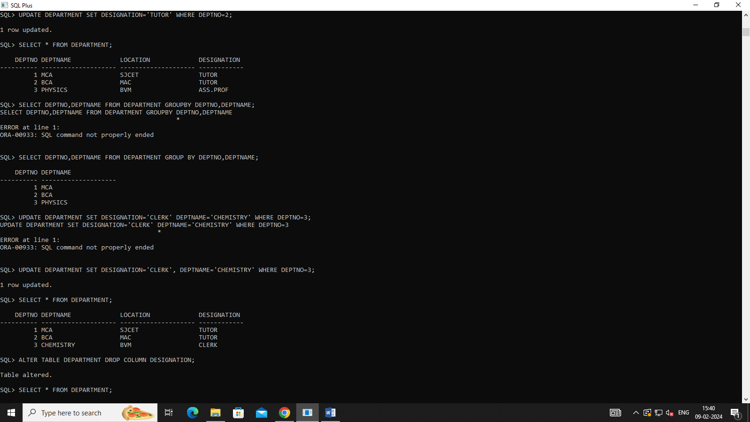

**3.**

**SQL> CREATE TABLE CUST(CUST_NAME VARCHAR(10),CUST_STREET VARCHAR(15),CUST_CITY VARCHAR(20));**

**Table created.**

**SQL> INSERT INTO CUST VALUES('&CUST_NAME','&CUST_STREET','&CUST_CITY');**

**Enter value for cust_name: ABIN**

**Enter value for cust_street: MADURAI**

**Enter value for cust_city: TAMILNADU**

**old 1: INSERT INTO CUST VALUES('&CUST_NAME','&CUST_STREET','&CUST_CITY')**

**new 1: INSERT INTO CUST VALUES('ABIN','MADURAI','TAMILNADU')**

**1 row created.**

**SQL> /**

**Enter value for cust_name: AJAY**

**Enter value for cust_street: AMEERPET**

**Enter value for cust_city: HYD**

**old 1: INSERT INTO CUST VALUES('&CUST_NAME','&CUST_STREET','&CUST_CITY')**

**new 1: INSERT INTO CUST VALUES('AJAY','AMEERPET','HYD')**

**1 row created.**

**SQL> SELECT *FROM CUST;**

**CUST_NAME CUST_STREET CUST_CITY**

**---------- --------------- --------------------**

**ABIN MADURAI TAMILNADU**

**AJAY AMEERPET HYD**

**SQL> ALTER TABLE CUST ADD(SALARY NUMBER(10));**

**Table altered.**

**SQL> SELECT * FROM CUST;**

**CUST_NAME CUST_STREET CUST_CITY SALARY**

**---------- --------------- -------------------- ----------**

**ABIN MADURAI TAMILNADU**

**AJAY AMEERPET HYD**

**SQL> ALTER TABLE CUST DROP COLUMN SALARY;**

**Table altered.**

**SQL> SELECT * FROM CUST;**

**CUST_NAME CUST_STREET CUST_CITY**

**---------- --------------- --------------------**

**ABIN MADURAI TAMILNADU**

**AJAY AMEERPET HYD**

**SQL> DELETE FROM CUST WHERE CUST_CITY='HYD';**

**1 row deleted.**

**SQL> SELECT * FROM CUST;**

**CUST_NAME CUST_STREET CUST_CITY**

**---------- --------------- --------------------**

**ABIN MADURAI TAMILNADU**

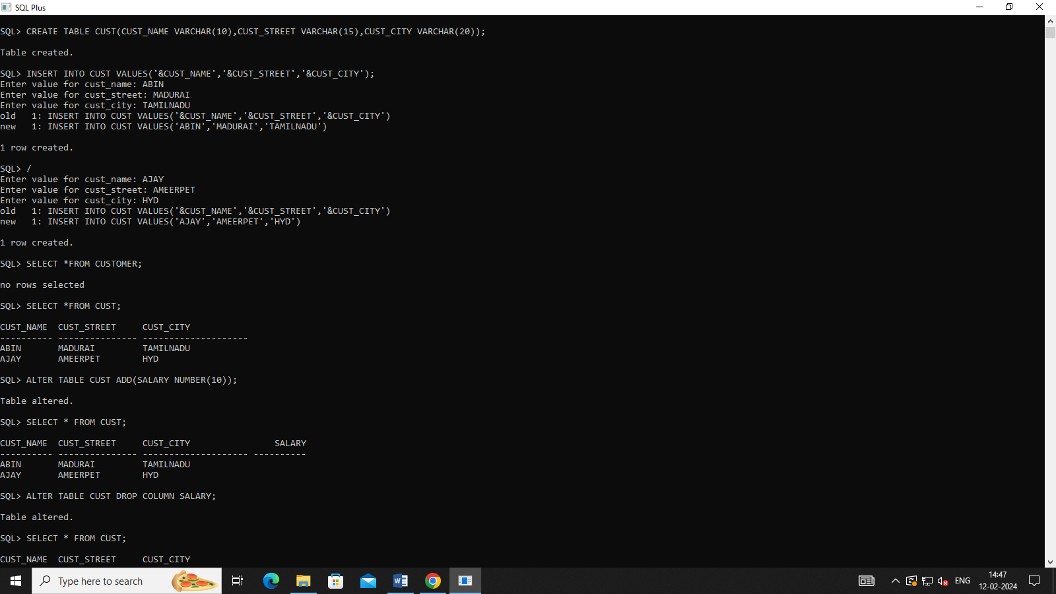

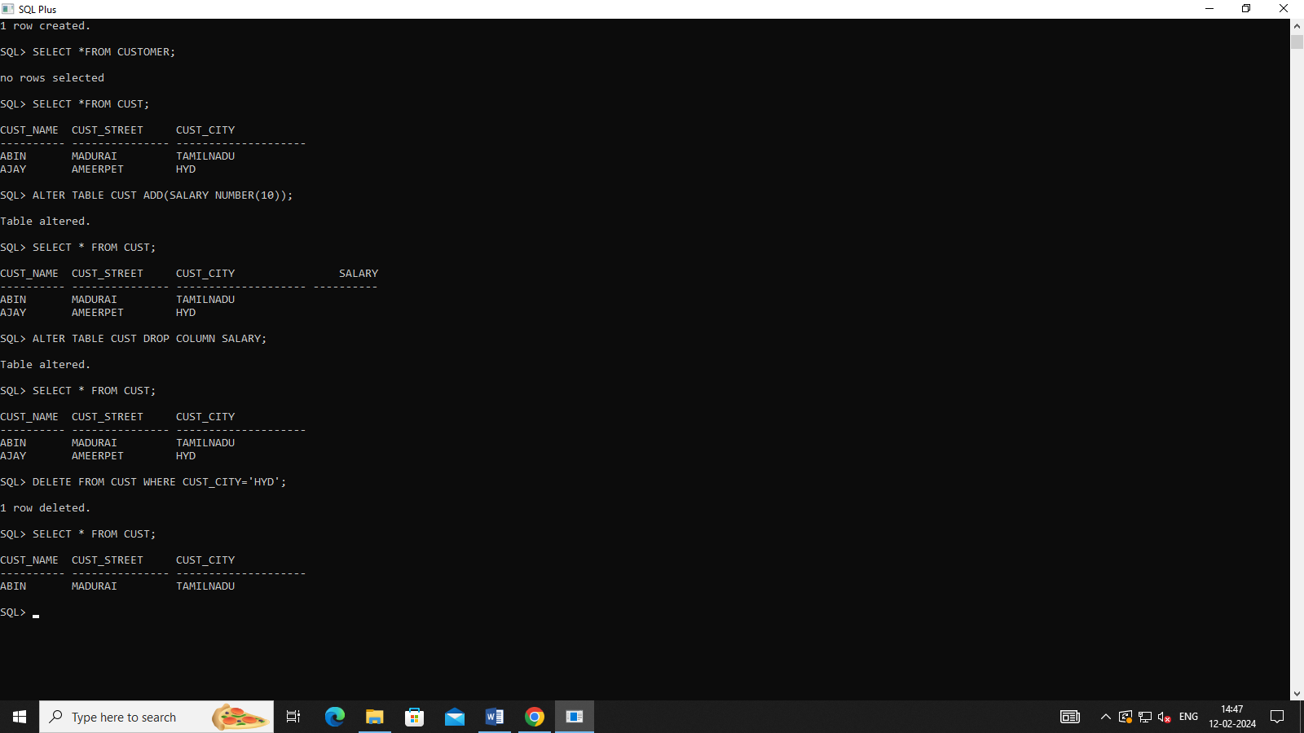

4.

SQL> CREATE TABLE BRANCH(BNAME VARCHAR(10),BCITY VARCHAR(15),ASSERTS VARCHAR(20));

Table created.

SQL> INSERT INTO BRANCH VALUES('&BNAME','&BCITY','&ASSERTS');

Enter value for bname: BRANCH1

Enter value for bcity: KOCHI

Enter value for asserts: 45

old 1: INSERT INTO BRANCH VALUES('&BNAME','&BCITY','&ASSERTS')

new 1: INSERT INTO BRANCH VALUES('BRANCH1','KOCHI','45')

1 row created.

Enter value for bname: BRANCH2

Enter value for bcity: KOTTAYAM

Enter value for asserts: 56

old 1: INSERT INTO BRANCH VALUES('&BNAME','&BCITY','&ASSERTS')

new 1: INSERT INTO BRANCH VALUES('BRANCH2','KOTTAYAM','56')

1 row created.

SQL> SELECT * FROM BRANCH;

BNAME BCITY ASSERTS

---------- --------------- --------------------

BRANCH1 KOCHI 45

BRANCH2 KOTTAYAM 56

SQL> INSERT INTO BRANCH VALUES('&BNAME','&BCITY','&ASSERTS');

Enter value for bname: BRANCH3

Enter value for bcity: KOLLAM

Enter value for asserts: 33

old 1: INSERT INTO BRANCH VALUES('&BNAME','&BCITY','&ASSERTS')

new 1: INSERT INTO BRANCH VALUES('BRANCH3','KOLLAM','33')

1 row created.

SQL> UPDATE BRANCH SET BNAME='BRANCH5' WHERE BCITY='KOLLAM';

1 row updated.

SQL> SELECT * FROM BRANCH;

BNAME BCITY ASSERTS

---------- --------------- --------------------

BRANCH1 KOCHI 45

BRANCH2 KOTTAYAM 56

BRANCH5 KOLLAM 33

SQL> ALTER TABLE BRANCH DROP COLUMN ASSERTS;

Table altered.

SQL> SELECT * FROM BRANCH;

BNAME BCITY

---------- ---------------

BRANCH1 KOCHI

BRANCH2 KOTTAYAM

BRANCH5 KOLLAM

